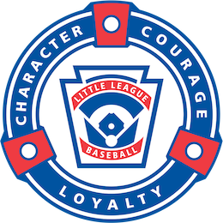Massapequa International

Little League, Inc.

P.O. Box 103, Massapequa Park, NY 11762

<https://www.massapequainternationalLL.com/>

Contact: [MILLsponsor@gmail.com](mailto:MILLsponsor@gmail.com)

September 2022

We are once again asking for your support of Massapequa International Little League. The success of our program is largely due to sponsors like you that provide financial assistance to our league. Your support allows for over 900 boys and girls to participate in our baseball and softball programs every year.

Massapequa International Little League is a Non-Profit organization and 100% of the funds received are invested in our league. The upcoming 2023 season will mark our 68th season of providing little league baseball and softball to the boys and girls of this community. Through the leadership of our all-volunteer Board of Directors, our mission is to teach the children of our community the fundamentals of the game and the importance of good sportsmanship and respect for fellow players, coaches and the game of baseball/softball.

Registration fees alone do not cover all of our expenses. The cost of insurance, uniforms, equipment and umpire fees continues to rise. Your donation will make a difference in a child’s life and have a positive influence on our community! Please review the Massapequa International Little League sponsorship form and consider becoming a League Sponsor. We have several sponsorship options and sponsorships are tax deductible. If you have any questions or would like additional information about our league, please contact your Board Member Representative or send email to MILLsponsor@gmail.com.

Thank you for helping the children of our community!